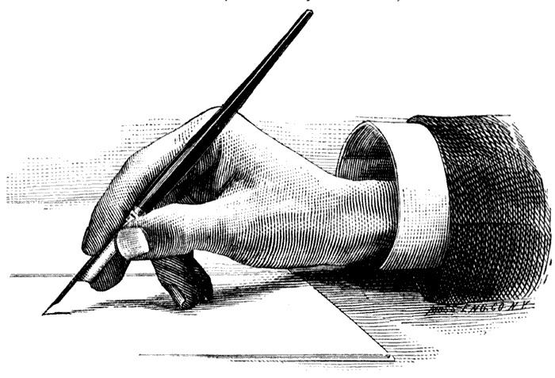Name:______________________________ Date:_______________________ Period:_____________

**A GUIDE TO WRITING A DBQ**

The purpose of the DBQ (Document Based Question) is **not** to test your knowledge of the subject, but rather to **evaluate your ability to work with the documents and use them to answer a question**.

Writing the DBQ is an acquired skill, one that takes practice – don’t get discouraged if you do not "get it" right away.

Remember that there is actually no right or wrong answer. Your answer is YOUR interpretation of the content of the documents. As long as your answer is logical and your interpretation is supported by the content of the document, you are correct!

***The following is your guide to writing a successful DBQ. Use this as a checklist when writing.***

**1.** **Carefully read the question prompt and the historical background.** Underline exactly what question(s) you need to answer and the terms that are unique to the question.

**2. Brainstorm a list of issues, historical terms, names, or events that are significant to that period of history.** When complete, you should examine this list to find similarities and break down the list into logical topics for each of your body paragraphs.

**2. Read the documents carefully.**

a. Make sure that you understand the document – if you don’t, ask!

b. What is the origin of the document?

c. Is the document based on actual events or is it hearsay (second hand information, opinion)?

d. What is the author's Point of View (POV)?

e. Where is the tension?

Are there people from the same place with a differing POV?

Is there bias?

f. If time, gender, or age were changed, would the person be saying the same thing?

**3. Plan to use *at least* one more than half the documents.** (If there are 10 documents total, you need to use at least 6)

**4. Your essay should be an ANALYSIS of the documents and their content. You are demonstrating analysis if you are doing the following:**

a. The essay contains a thesis, which divides your answer into categories.

b. The documents are used as evidence to support your thesis.

c. Frequent reference is made to the terms used in question.

d. Your answer is always focused directly on the question being asked.

**5. Introductory Paragraph**

1. Write an introductory sentence that sets the scene or states a relevant idea.
2. Briefly lay out a counter-argument: other possible answer(s) to the question.
3. “BUT” (however, yet, still, although...)
4. Write one clear sentence that states the thesis, or main idea(s), your essay will prove.
5. Specify three or four sub-topics to the thesis: logical segments or divisions of the overall thesis. Elaborate on each of these sub-topics with simple defining sentences.

**6. Main Body Paragraphs**

1. Begin with a topic sentence which re-introduces one of the sub-topics.
2. Support that topic sentence with outside information from your brainstorm list.
3. Support your outside information with a reference to one or more of the supplied primary sources.
4. Be sure to use and cite the documents properly.
5. In the words of M. L. Rampolla, "Do not quote when you can paraphrase." Merely copying from the documents does nothing to make your argument. You **must** tell me why that document is important.
6. Write a concluding sentence, which relates the paragraph's topic back to the thesis.
7. Write a transitional sentence introducing the next topic.

**DBQ Dos & Don’ts**

|  |  |
| --- | --- |
| ***Do the following things with a DBQ*** | ***Don't do the following things with a DBQ*** |
| Read carefully and make sure you understand the question being asked. | Respond to a question that isn't asked. |
| Quickly jot down the major themes/events/people you associate with this topic or question. | Use "I" statements such as "I think that Document A portrays..." |
| Read over the documents, noting the year and author/source of each one. If the document seems to support or oppose a possible perspective or opinion on the question, note that in the margin. | Summarize the documents. The reader knows the content of the documents and is interested in how you view the document relating to the question. |
| Write out a preliminary thesis and outline of your major points. | Quote long passages from the documents. Use an ellipsis "..." if you need to quote. |
| As you begin to write, remember to weave the documents into your answer, always focusing on the thesis. | Try to impress the reader with big words that are used incorrectly. This has the opposite effect of what is intended. |
| Include your knowledge of the era along with your analysis of the documents. | Spend so much time reading and underlining the documents that you have to rush your writing. |
| Be sure to include your own analysis/perspective on the question. | Begin writing your answer until you have a good sense of your thesis and how you want to approach the question. |
| If you can knowledgeably quote or refer to an historian who has a perspective on this question, include his or her perspective. | Write "I ran out of time" on the bottom of your essay. It gives Ms. Schram an eye-twitch. |
| Keep an eye on the clock so that you can have time to re-read your essay for any obvious technical errors. |  |
| Be as specific as possible when you include historical information. |  |
| Be assertive and forceful in making your points. |  |