Support Materials for
Core Content for Assessment

Version 4.1

Mathematics

August 2007
Kentucky Department of Education
Introduction to Depth of Knowledge (DOK) - Based on Norman Webb’s Model
(Karin Hess, Center for Assessment/NCIEA, 2005)

According to Norman L. Webb (“Depth of Knowledge Levels for Four Content Areas,” March 28, 2002), interpreting and assigning depth of knowledge levels to both objectives within standards and assessment items is an essential requirement of alignment analysis.

Four Depth of Knowledge (DOK) levels were developed by Norman Webb as an alignment method to examine the consistency between the cognitive demands of standards and the cognitive demands of assessments

Depth of Knowledge (DOK) Levels for Mathematics

A general definition for each of the four (Webb) Depth of Knowledge levels is followed by Table 1, which provides further specification and examples for each of the DOK levels for mathematics. Webb recommends that large-scale, on-demand assessments only assess Depth of Knowledge Levels 1, 2, and 3, due primarily to testing time constraints. Depth of Knowledge at Level 4 in mathematics is best reserved for local assessment. Table 2 provides examples of DOK “ceilings” (the highest level of cognitive demand for large-scale assessment) using Kentucky’s mathematics grade level expectations.

Descriptors of DOK Levels for Mathematics (based on Webb, Technical Issues in Large-Scale Assessment, report published by CCSSO, December 2002)

Recall and Reproduction – Depth of Knowledge (DOK) Level 1
Recall and Reproduction includes the recall of information such as a fact, definition, term, or a simple procedure, as well as performing a simple algorithm or applying a formula. That is, in mathematics a one-step, well-defined, and straight algorithmic procedure should be included at this lowest level. Other key words that signify a Level 1 include “identify,” “recall,” “recognize,” “use,” and “measure.” Verbs such as “describe” and “explain” could be classified at different levels depending on what is to be described and explained.

Some examples that represent but do not constitute all of Level 1 performance are:
- Identify a diagonal in a geometric figure.
- Multiply two numbers.
- Find the area of a rectangle.
- Convert scientific notation to decimal form.
- Measure an angle.
Skills and Concepts/Basic Reasoning – Depth of Knowledge (DOK) Level 2
Skills and Concepts/Basic Reasoning includes the engagement of some mental processing beyond a habitual response. A Level 2 assessment item requires students to make some decisions as to how to approach the problem or activity, whereas Level 1 requires students to demonstrate a rote response, perform a well-known algorithm, follow a set procedure (like a recipe), or perform a clearly defined series of steps. Keywords that generally distinguish a Level 2 item include “classify,” “organize,” ”estimate,” “make observations,” “collect and display data,” and “compare data.” These actions imply more than one step. For example, to compare data requires first identifying characteristics of the objects or phenomenon and then grouping or ordering the objects. Some action verbs, such as “explain,” “describe,” or “interpret” could be classified at different levels depending on the object of the action. For example, if an item required students to explain how light affects mass by indicating there is a relationship between light and heat, this is considered a Level 2. Interpreting information from a simple graph, requiring reading information from the graph, also is a Level 2. Interpreting information from a complex graph that requires some decisions on what features of the graph need to be considered and how information from the graph can be aggregated is a Level 3. Caution is warranted in interpreting Level 2 as only skills because some reviewers will interpret skills very narrowly, as primarily numerical skills, and such interpretation excludes from this level other skills such as visualization skills and probability skills, which may be more complex simply because they are less common. Other Level 2 activities include explaining the purpose and use of experimental procedures; carrying out experimental procedures; making observations and collecting data; classifying, organizing, and comparing data; and organizing and displaying data in tables, graphs, and charts.

Some examples that represent but do not constitute all of Level 2 performance are:
- Classify quadrilaterals.
- Compare two sets of data using the mean, median, and mode of each set.
- Determine a strategy to estimate the number of jellybeans in a jar.
- Extend a geometric pattern.
- Organize a set of data and construct an appropriate display.

Strategic Thinking/Complex Reasoning – Depth of Knowledge (DOK) Level 3
Strategic Thinking/Complex Reasoning requires reasoning, planning, using evidence, and a higher level of thinking than the previous two levels. In most instances, requiring students to explain their thinking is a Level 3. Activities that require students to make conjectures are also at this level. The cognitive demands at Level 3 are complex and abstract. The complexity does not result from the fact that there are multiple answers, a possibility for both Levels 1 and 2, but because the task requires more demanding reasoning. An activity, however, that has more than one possible answer and requires students to justify the response they give would most likely be a Level 3. Other Level 3 activities include drawing conclusions from observations; citing evidence and developing a logical argument for concepts; explaining phenomena in terms of concepts; and using concepts to solve problems.
Some examples that represent but do not constitute all of Level 3 performance are:
- Write a mathematical rule for a non-routine pattern.
- Explain how changes in the dimensions affect the area and perimeter/circumference of geometric figures.
- Determine the equations and solve and interpret a system of equations for a given problem.
- Provide a mathematical justification when a situation has more than one possible outcome.
- Interpret information from a series of data displays.

Extended Thinking/Reasoning – Depth of Knowledge (DOK) Level 4
Extended Thinking/Reasoning requires complex reasoning, planning, developing, and thinking most likely over an extended period of time. The extended time period is not a distinguishing factor if the required work is only repetitive and does not require applying significant conceptual understanding and higher-order thinking. For example, if a student has to take the water temperature from a river each day for a month and then construct a graph, this would be classified as a Level 2. However, if the student is to conduct a river study that requires taking into consideration a number of variables, this would be a Level 4. At Level 4, the cognitive demands of the task should be high and the work should be very complex. Students should be required to make several connections—relate ideas within the content area or among content areas—and have to select one approach among many alternatives on how the situation should be solved, in order to be at this highest level. Level 4 activities include designing and conducting experiments; making connections between a finding and related concepts and phenomena; combining and synthesizing ideas into new concepts; and critiquing experimental designs.

Some examples that represent but do not constitute all of Level 4 performance are:
- Collect data over time taking into consideration a number of variables and analyze the results.
- Model a social studies situation with many alternatives and select one approach to solve with a mathematical model.
- Develop a rule for a complex pattern and find a phenomenon that exhibits that behavior.
- Complete a unit of formal geometric constructions, such as nine-point circles or the Euler line.
- Construct a non-Euclidean geometry.

Table 1: Applying Webb’s Depth of Knowledge Levels for Mathematics
(Adapted from Karin Hess, Center for Assessment/NCIEA
by the Kentucky Department of Education, 2005)
Webb’s DOK Levels
Recall and Reproduction (DOK 1) | Skills and Concepts/  Basic Reasoning  (DOK 2) | Strategic Thinking/  Complex Reasoning  (DOK 3) | Extended Thinking/  Reasoning  (DOK 4)
- Recall of a fact, information or procedure  - Recall or recognize fact  - Recall or recognize definition  - Recall or recognize term  - Recall and use a simple procedure  - Perform a simple algorithm.  - Follow a set procedure  - Apply a formula  - A one-step, well-defined, and straight algorithm procedure.  - Perform a clearly defined series of steps  - Identify  - Recognize  - Use appropriate tools  - Measure  - Habitual response: Can be described; Can be explained  - Answer item automatically  - Use a routine method  - Recognize patterns  - Retrieve information from a graph  - Includes one step word problems  - Do basic computations | - Students make some decisions as to how to approach the problem  - Skill/Concept  - Basic Application of a skill or concept  - Classify  - Organize  - Estimate  - Make observations  - Collect and display data  - Compare data  - Imply more than one step  - Visualization Skills  - Probability Skills  - Explain purpose and use of experimental procedures.  - Carry out experimental procedures  - Make observations and collect data  - Beyond habitual response  - Classify, organize and compare data.  - Explain, describe or interpret  - Organize and display data in tables, charts and graphs.  - Use of information  - Two or more steps, procedures  - Demonstrate conceptual knowledge through models and explanations.  - Extend a pattern.  - Explain concepts, relationships, and nonexamples. | - Requires reasoning, planning using evidence and a higher level of thinking  - Strategic Thinking  - Freedom to make choices  - Explain your thinking  - Make conjectures  - Cognitive demands are complex and abstract  - Conjecture, plan, abstract, explain  - Justify  - Draw conclusions from observations  - Cite evidence and develop logical arguments for concepts  - Explain phenomena in terms of concepts  - Use concepts to solve problems  - Make and test conjectures  - Some complexity  - Provide math justification when more than one possible answer  - Non-routine problems  - Interpret information from a complex graph  - Analyze, synthesize  - Weigh multiple things. | - Performance tasks  - Authentic writing  - Project-based assessment  - Complex, reasoning, planning, developing and thinking  - Cognitive demands of the tasks are high  - Work is very complex  - Students make connections within the content area or among content areas  - Select one approach among alternatives  - Design and conduct experiments  - Relate findings to concepts and phenomena  - Combine and synthesize ideas into new concepts  - Critique experimental designs

Table 2: Depth of Knowledge Sample Chart -
Using the Same Content Statement Across DOK levels/Grade spans
(Kentucky Department of Education, 2005)
MA-05-5.1.1
Students will extend patterns, find the missing term(s) in a pattern or describe rules for patterns (numbers, pictures, tables, words) from real-world and mathematical problems. DOK - 3
Webb’s DOK Levels
Recall and Reproduction (DOK 1) | Skills and Concepts/  Basic Reasoning  (DOK 2) | Strategic Thinking/  Complex Reasoning  (DOK 3) | Extended Thinking/  Reasoning  (DOK 4)
Find the next three terms in the following pattern:  2/7, 4/7, 6/7, 8/7. … | Draw the next figure in the following pattern: | Find the next three terms in the pattern and determine the rule for the following pattern of numbers:  1, 4, 8, 11, 15, 18, 22, 25, 29, … | Find the next three terms in the pattern, determine the rule for finding the next number in the pattern, and make or find a model for the pattern:  1, 1, 2, 3, 5, 8, 13, 21, 34, …
MA-08-1.4.1
Students will apply ratios and proportional reasoning to solve real-world problems (e.g., percents, constant rate of change, unit pricing, percent of increase or decrease). DOK - 3
The price of gasoline was $2.159 per gallon last week. This week the new price is $2.319 per gallon. Determine the percent of increase. | On a trip across the country, Justin determined that he would have to drive about 2,763 miles. What speed would he have to average to complete the trip in no more than 50 hours of driving time? | A sweater that you really been want has just been placed on sale. The original cost was $63.99. The sale price is $47.99. What is the percent of decrease from the original price? You still do not have enough money saved up to purchase the sweater, so you wait just a little longer and the store now has an ad that states that all items currently on sale have been reduced by 1/3 of the sale price. What is the new sale price? What is the overall percent of decrease from the original price? | Students will visit three local grocery stores and find the prices of three different sizes of the same product at the three stores. Students will then determine the unit price for each size item at each store and make a decision as to which is the best buy. Students will then write a report chronicling their work and reporting which is the best buy, justifying their decision with their mathematical work.

MA-HS-3.2.1
Students will identify and describe properties of and apply geometric transformations within a plane to solve real-world and mathematical problems. DOK - 3
Students will identify a transformation within a plane. | Students will perform a compound transformation of a geometric figure within a coordinate plane. | Students will perform a geometric transformation to meet specified criteria and then explain what does or does not change about the figure. | Students will abstract the transformations occurring in an Escher woodprint and then create a simplified tessellation of their own.

Table 3: Depth of Knowledge Sample Chart
Using Same Verb Across DOK Levels and Grade Spans
(Kentucky Department of Education, 2005)
Mathematics Core Content Statement | Ceiling | Recall and Reproduction (DOK 1) | Skills and Concepts/  Basic Reasoning  (DOK 2) | Strategic Thinking/  Complex Reasoning  (DOK 3) | Extended Thinking/  Reasoning  (DOK 4)
MA-05-3.3.1  Students will identify and graph ordered pairs on a positive coordinate system scaled by ones, twos, threes, fives, or tens; locate points on a grid; and apply graphing in the coordinate system to solve real-world problems. | 2 | Students will graph the point (1,6) in the first quadrant of the coordinate plane. | Students will graph the vertices of the reflected image of a triangle. | Given the coordinates for three vertices of a rectangle, students will graph the coordinates of the fourth vertex. | Students will graph the vertices of a triangle onto positive coordinate planes using different scales and analyze what changes in the figure are affected by the changes in scales and explain why.
MA-08-3.3.1  Students will identify and graph ordered pairs on a coordinate system, correctly identifying the origin, axes and ordered pairs; and will apply graphing in the coordinate system to solve real-world and mathematical problems. | 2 | Students will graph the point (2/3, -4 3/8). | Students will graph the vertices of a rectangle and compare the diagonals. | Students will graph the vertices of a quadrilateral and determine its classification. | Students will graph a variety of two-dimensional figures and analyze them to determine classifications.
MA-HS-3.3.1  Students will apply algebraic concepts and graphing in the coordinate plane to analyze and solve problems (e.g., finding the final coordinates for a specified polygon, midpoints, betweenness of points, parallel and perpendicular lines, the distance between two points, the slope of a segment). | 2 | Given the coordinates of the endpoints of a segment, graph the midpoint of the segment. | Given three vertices of a parallelogram, graph the coordinates of the fourth vertex. | Graph the four vertices of a quadrilateral, and then use slope and distance formulas to determine the best classification for the quadrilateral. | In an equilateral triangle, graph the perpendicular bisectors of each side using slope and midpoint, and then compare those results with constructions using a compass and straightedge. Compare and contrast the results.
Depth of Knowledge (DOK)
2004 Released Items – Mathematics
(Kentucky Department of Education, 2005)

Elementary (Grade 5)

1. José had 64 baseball cards. He gave 12 cards to his sister. Then he divided the remaining cards equally among his FOUR friends. How many cards did each of his friends get?
- 13 cards
- 16 cards
- 17 cards
- 18 cards

Use the figure below to answer question 2.

2. How many edges does the figure above have?
- 6
- 8
- 12
- 16

Use the bar graph below to answer question 3.

3. Which age group received twice as many trophies as the 4-year-olds?
- 3-year-olds
- 5-year-olds
- 6-year-olds
- 10-year-olds

4. What is the rule for this pattern?
2, 1, 3, 2, 4, 3, 5, 4, 6
- subtract 1, multiply by 3
- add 2, add 3
- subtract 1, add 2
- multiply by 2, divide by 1

A Fractional Part
5. Mrs. Washington asked her students what fractional part of these 12 circles is shaded.

Odessa thinks the answer is $\frac{9}{\text{12}}$.
Bob thinks the answer is $\frac{3}{4}$.
- Who is correct – Odessa, Bob, or both?
- Write how you would explain your answer to part a to Odessa and Bob. Draw your own picture to go with your explanation.

Congruent Shapes
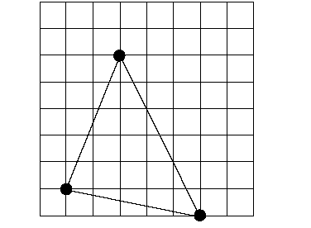

6. Sometimes shapes are congruent to one another.
- On the grid provided on the next page, draw a shape that is CONGRUENT to the shape above. Label the congruent shape with a “C.”
- Draw a shape that is NOT CONGRUENT to the shape above. Label the not congruent shape “NC.”
- Explain why the CONGRUENT shapes are congruent.
- Explain why the NOT CONGRUENT shape is not congruent.

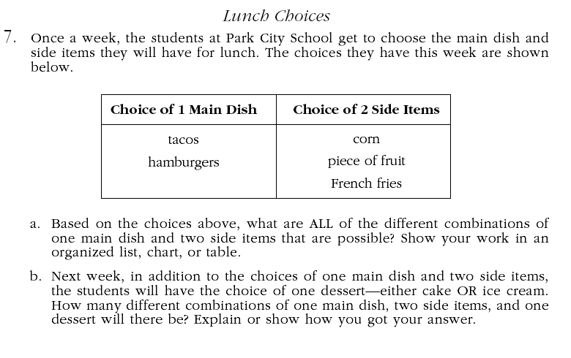
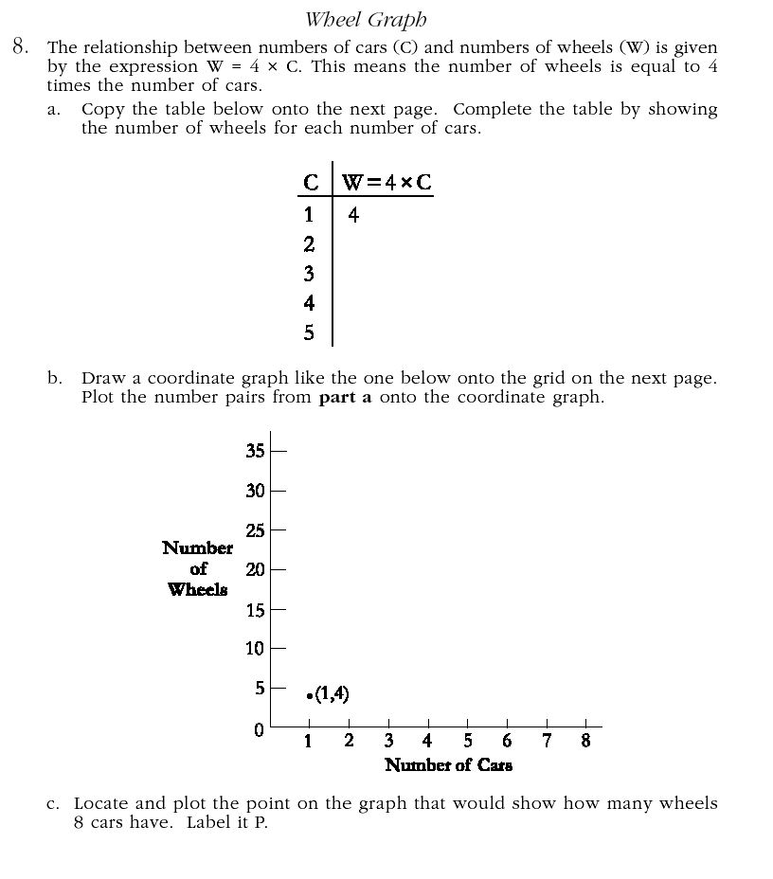
Middle School (Grade 8)

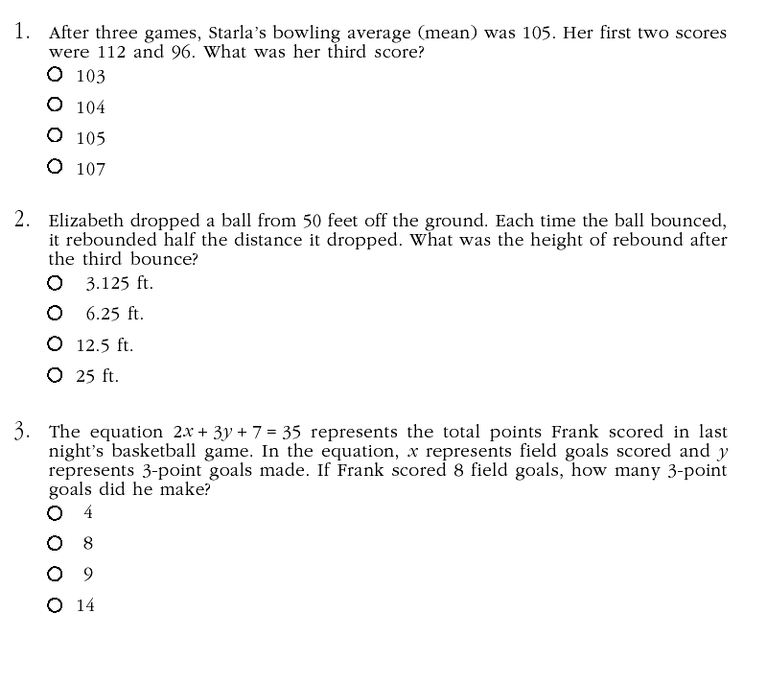

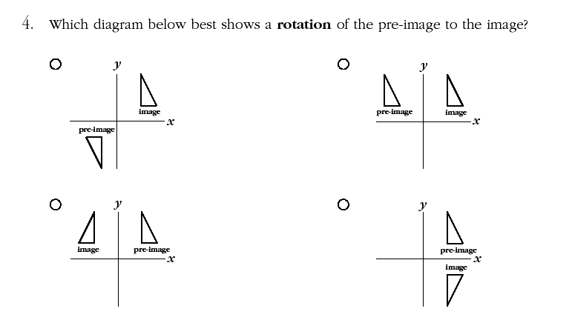
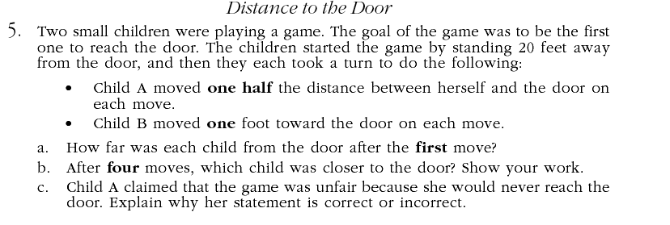

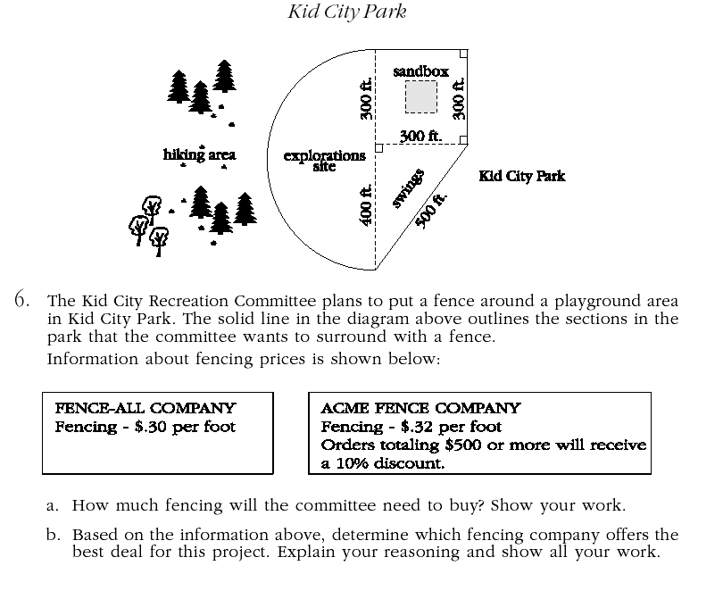
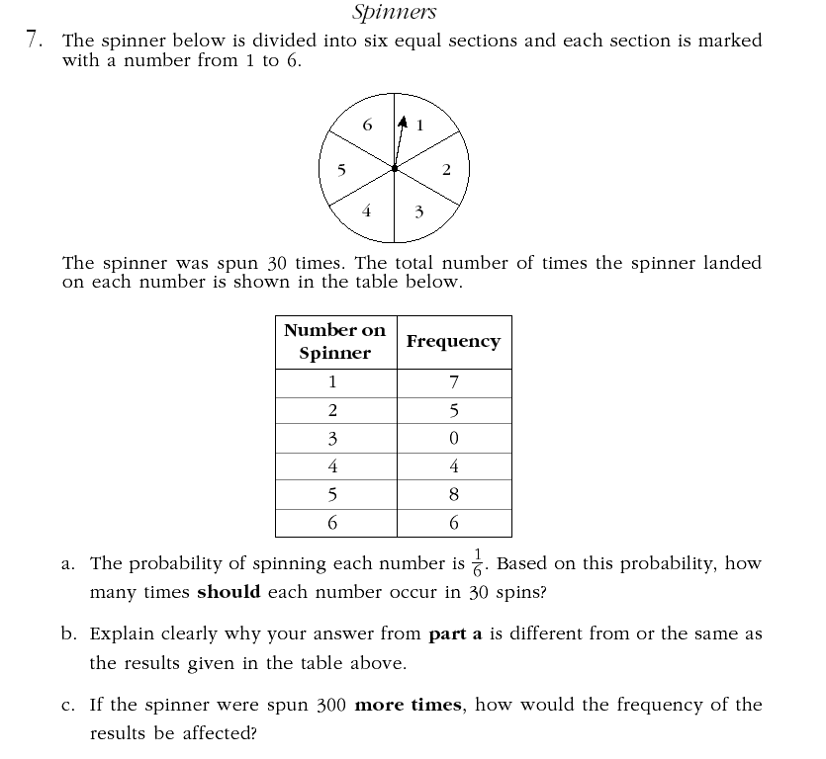
High School (Grade 11)
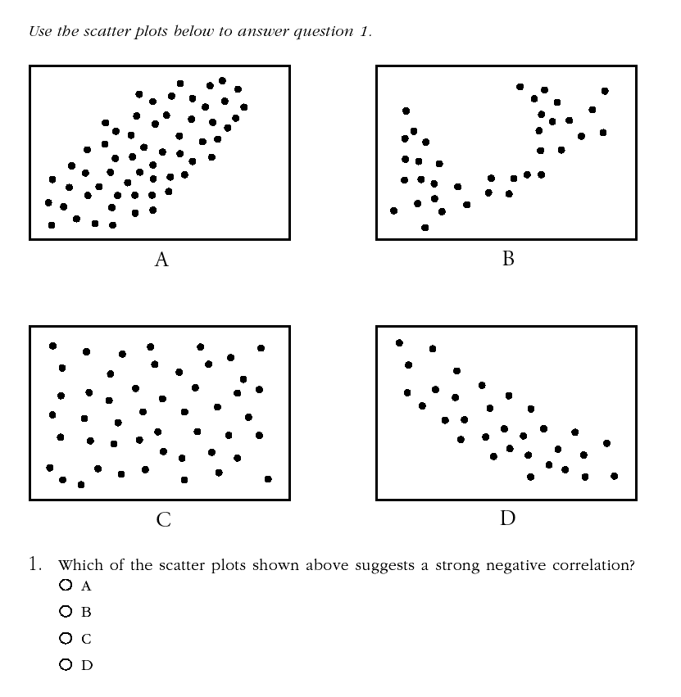
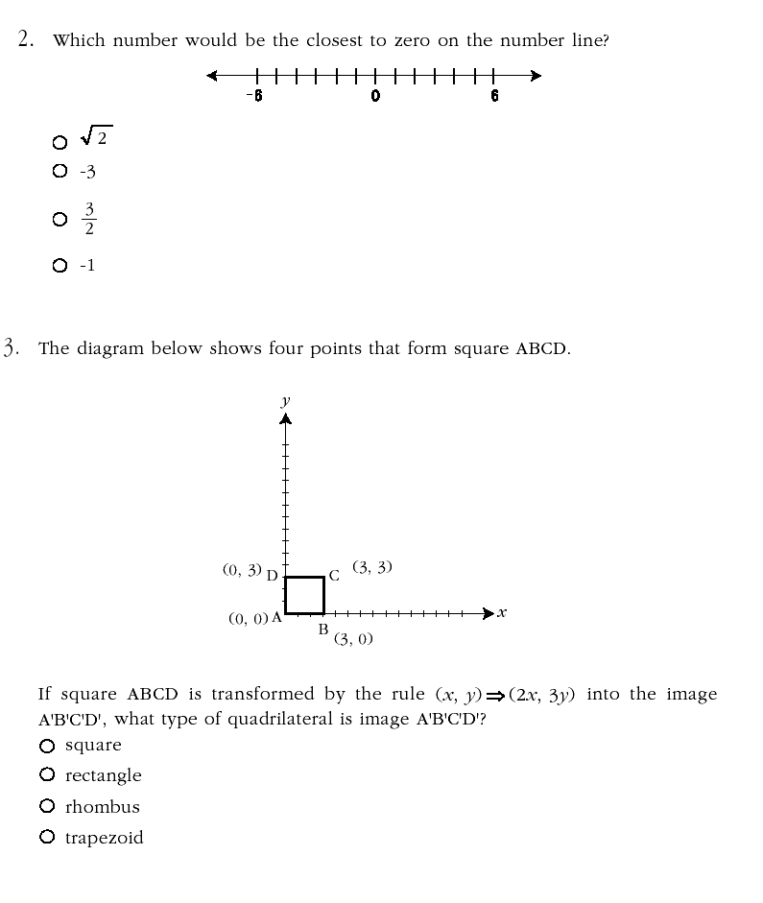
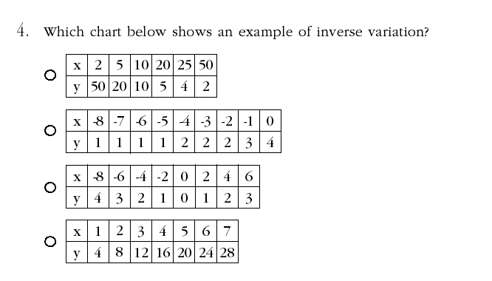
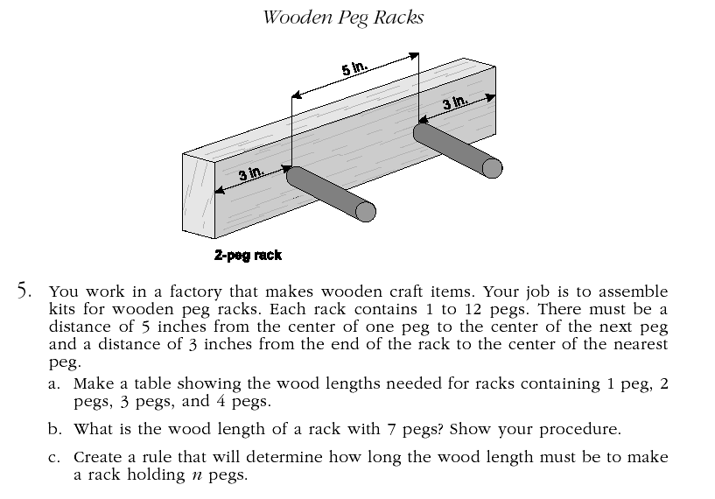
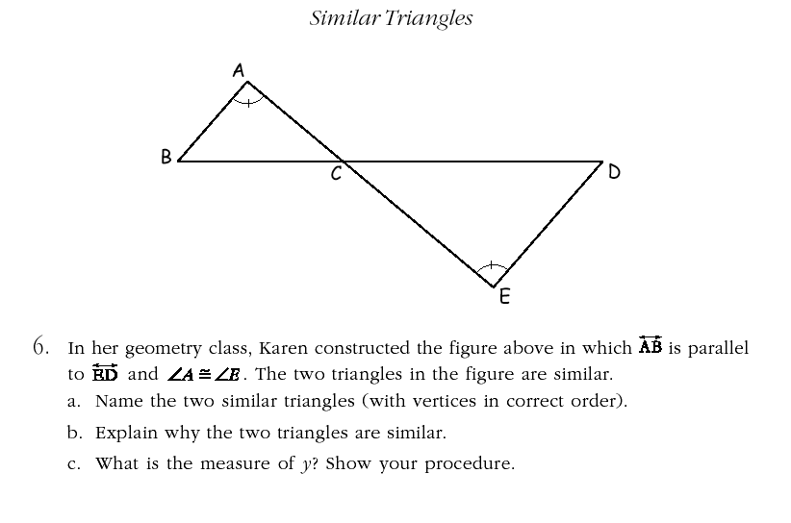
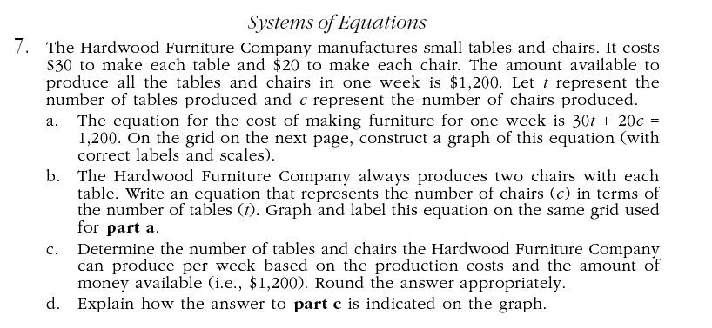
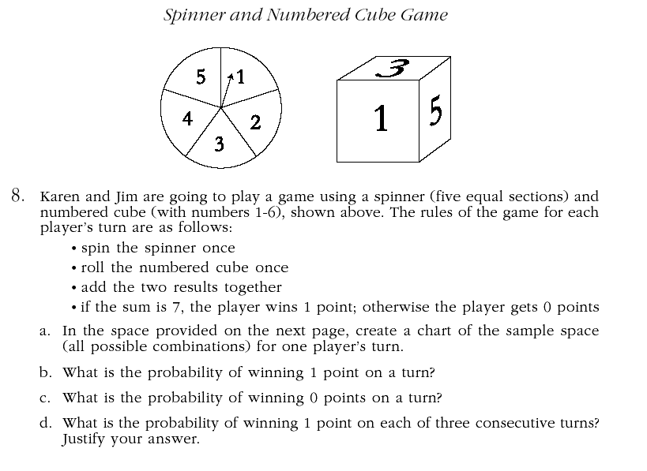
Dept of Knowledge (DOK) Annotations

Mathematics 2004 Released Items

Grade 5 -- Mathematics
Subject | Grade Level | Item  Number | DOK Level | CCA  V. 4.1 | Annotation
Mathematics | 5 | 1 | 2 | MA-05-1.3.1 | This item is an application of computational algorithms. It is a multi-step problem requiring the student to make a decision of how to approach the computations.
Mathematics | 5 | 2 | 1 | MA-05-3.1.1 | The student merely has to recall the definition of an edge and then count the edges that are illustrated in the figure.
Mathematics | 5 | 3 | 2 | MA-05-4.1.1 | The student is interpreting information from a simple graph.
Mathematics | 5 | 4 | 2 | MA-05-5.1.1 | The student is recognizing and identifying a pattern that contains two different operations.
Mathematics | 5 | 5 | 2 | MA-05-1.1.3 | This item requires students to compare different interpretations of a simple diagram. While the process may be somewhat complex for fifth graders, it is not abstract enough to reach a level 3. The response requires explanation, but not justification.
Mathematics | 5 | 6 | 2 | MA-05-3.1.5 | Students are asked to create both an example and a non-example of “congruent.” They must apply the concept of congruent and provide reasons for why the figures are congruent and non-congruent.
Mathematics | 5 | 7 | 3 | MA-05-4.4.1 | Students must choose a strategy to solve the problem. The response requires the student to use planning and evidence from the table supported with a mathematical explanation to justify their answer.
Mathematics | 5 | 8 | 2 | MA-05-5.1.2 | Although the student is performing basic algorithms to complete the table, some planning is involved in designing the graph on which to plot the points.

Dept of Knowledge (DOK) Annotations

Mathematics 2004 Released Items

Grade 8 -- Mathematics
Subject | Grade Level | Item  Number | DOK Level | CCA  V. 4.0 | Annotation
Mathematics | 8 | 1 | 2 | MA-08-4.2.1 | The item is a multi-step problem requiring mental processing. The student must use the concept of a mean and apply the formula to arrive at a solution.
Mathematics | 8 | 2 | 2 | MA-08-5.1.1 | The student must recognize and apply a real-world pattern using multiple steps.
Mathematics | 8 | 3 | 2 | MA-08-5.3.1 | The student has to substitute for a variable and apply the order of operations to solve the multi-step equation.
Mathematics | 8 | 4 | 1 | MA-08-3.2.1 | The student must recognize or identify a rotation.
Mathematics | 8 | 5 | 3 | MA-08-5.1.2  MA-08-1.1.2 | The problem involves an abstract idea requiring multiple steps supported with a mathematical explanation to justify the answer.
Mathematics | 8 | 6 | 2 | MA-08-2.1.1 | Students have to determine the appropriate formulas and apply them to solve the problem.
Mathematics | 8 | 7 | 3 | MA-08-4.4.2 | This level 3 problem requires application of the abstract concepts of theoretical and experimental probability. Students must compare theoretical/experimental probability and make a conjecture.

Dept of Knowledge (DOK) Annotations

Mathematics 2004 Released Items

Grade 11 -- Mathematics
Subject | Grade Level | Item  Number | DOK Level | CCA  V. 4.0 | Annotation
Mathematics | 11 | 1 | 1 | MA-HS-4.2.1 | Students only need to know the definition of negative correlation (the relationship between two variables).
Mathematics | 11 | 2 | 1 | MA-HS-1.1.1 | Students are locating points on a number line, and then comparing the points’ location in relation to 0.
Mathematics | 11 | 3 | 2 | MA-HS-3.2.1 | This is a multi-step problem involving applying the algorithm for dilation and then identifying the resulting image.
Mathematics | 11 | 4 | 1 | MA-HS-5.1.7 | The student must only recognize which set of data fits the definition of an inverse variation.
Mathematics | 11 | 5 | 2 | MA-HS-5.1.1 | There is only one possible answer for each response. Students must make some decisions in planning their approach to the rule. They interpret data from the table they create.
Mathematics | 11 | 6 | 2 | MA-HS-3.1.13 | Explaining why the two triangles are similar is accomplished primarily by citing the AA Similarity theorem and demonstrating how it applies. The student must correctly set up the proportion in order to determine the value for y.
Mathematics | 11 | 7 | 3 | MA-HS-5.3.4 | This problem requires reasoning, planning, using evidence, and higher level thinking. This multi-step problem includes substituting for a variable, creating a graph, formulating an equation and then interpreting the results from that graph.
Mathematics | 11 | 8 | 2 | MA-HS-4.4.1 | The student is not asked to justify any of their results. They must plan the sample space chart, and then interpret the data displayed in that chart. Part d is mostly algorithmic if the student knows how to compute the probability.

