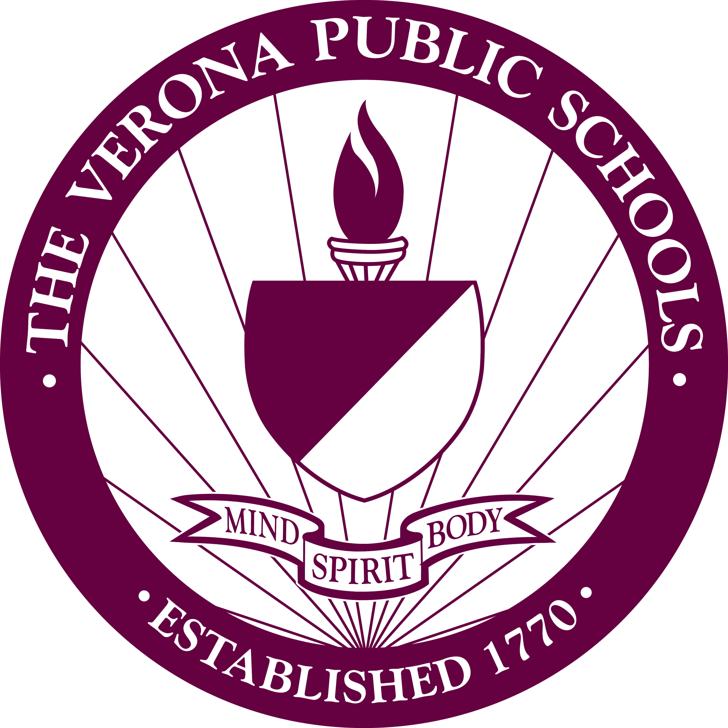 | Verona Public Schools  Office of Curriculum & Instruction

Name: |  | Date:

Pre-Conference Form: Formal Observation

This is the pre-conference form for the first round observations for the 2014-15 school year. Please complete questions 1 through 4 and be prepared to discuss them at the pre-conference. Thank you☺

- Clearly state the Daily Objective(s) and their connection to the Standards.

- List of procedures/activities for the lesson (e.g., Warm up, Teacher led PowerPoint, think-pair share, video clip, teacher led discussion, exit card).

- How do you know if your students have met the objective(s)?

- Please identify up to 8 to 10 “Potential” Marzano Elements that are evident in your lesson.

