Surface Area of 3-D Figures

Essential Question: How is the surface area of a 3-D figure related to a 2-D picture?

Do Now:

Imagine that you cut some edges of a cereal box and unfold it. Use the given dimensions and try to find the sum of the areas of the faces.

Original Cereal Box Unfolded Cereal Box
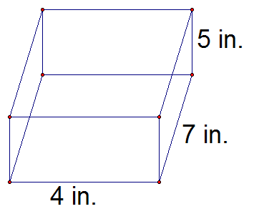

Surface Area-

Lateral Area-

Surface Area of a Polyhedron General Formula=

Surface Area Formulas to Use

You may use these formulas to fill in surface area formulas of polyhedrons

Area of a Triangle  $$A=\frac{1}{2}bh$$ | Area of a Circle  $$A=πr^{2}$$ | Area of a Quadrilateral  $$A=l x w$$

Surface Area of Right Prism

S=

Key Question to Ask:

Surface Area of a Right Cylinder

S=

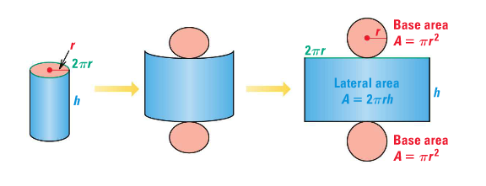

Surface Area of a Regular Pyramid

S=  B=  P=  $l$= | 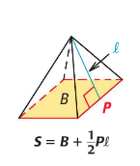

Surface Area of a Right Cone

S=  $$r=$$  $$l=$$ | 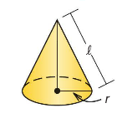

Example Problems

1. Find the surface area of the right prism

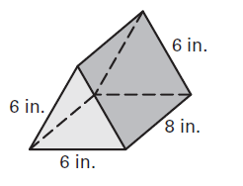

2. Find the surface area of a right rectangular prism with height 5 feet, length 11 feet and width 4 feet.

3. Find the surface area of the cylinder. Round your answer to two decimal places.
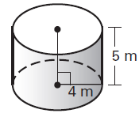

4. Find the surface area of a right cylinder with height 9 centimeters and radius 6 centimeters. Round your answer to two decimal places.

Day 1 HW: p. 806-807 #3, 4, 6, 7, 10, 12, 13, 14
5. a. Find the area of each lateral face of the lateral square pyramid.
b. Find the surface area of the square pyramid.

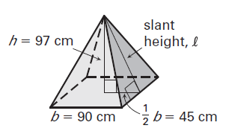

6. Find the surface area of the cone.
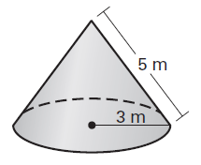

Independent Practice

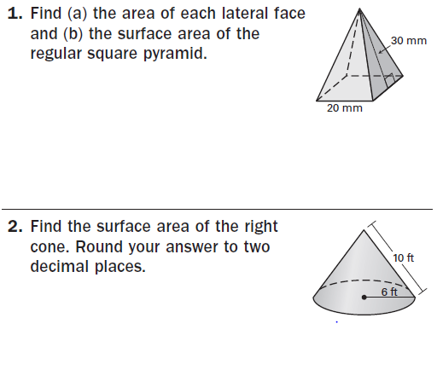
Day 2 HW: p. 814-815 #5, 6, 8, 9, 13, 15, 23

