Name

Class

Date

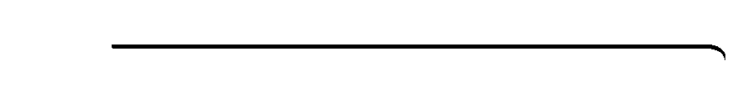

**Practice**

**Practice**

**Practice**

*Form G*

4-5

Using Corresponding Parts of Congruent Triangles

**For each pair of triangles, tell why the two triangles are congruent. Give the congruence statement. Then list all the other corresponding parts of the triangles that are congruent.**

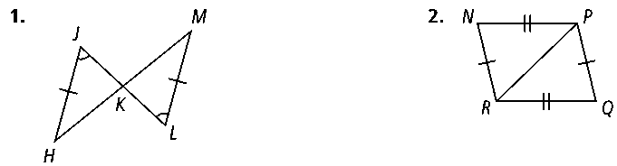**1. 2.**

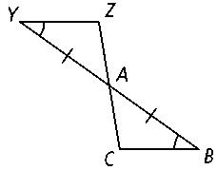**3.** Complete the proof.

**Given: **≅ *,* ∠*B* ≅ ∠*Y* **Prove: **≅ 

|  |  |
| --- | --- |
| **Statements** | **Reasons** |
| 1) **≅***,* ***∠****B* **≅**∠*Y* | 1) hari |
| 2) ∠*YAZ* and *∠BAC* are vertical angles. | 2) Definition of vertical angles |
| 3) *∠YAZ* **≅**∠*BAC* | 3)hari |
| 4) hari | 4)hari |
| 5)hari | 5)hari |

**4. Open-Ended** Construct a figure that involves two congruent triangles. Set up given statements and write a proof that corresponding parts of the triangles are congruent.

**Prentice Hall Gold Geometry •** Teaching Resources

Copyright © by Pearson Education, Inc., or its affiliates. All Rights Reserved.

**33**

Name

Class

Date

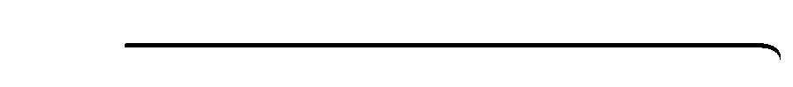

**Practice** (continued)

*Form G*

4-5

Using Corresponding Parts of Congruent Triangles

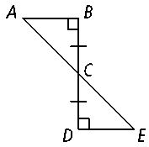**5.** Complete the proof.

**Given: ** ** *,  * *, *

**Prove:** ∠*A* ≅ ∠*E*

|  |  |
| --- | --- |
| **Statements** | **Reasons** |
| 1) *,* | 1) hari |
| 2) ∠*CDE* and ∠*CBA* are right angles. | 2) Definition of right angles |
| 3) *∠CDE* **≅**∠*CBA* | 3)hari |
| 4) hari | 4) Vertical angles are congruent. |
| 5) **≅** | 5)hari |
| 6)hari | 6)hari |
| 7) ***∠****A* **≅**∠*E* | 7)hari |

**Prentice Hall Gold Geometry •** Teaching Resources

Copyright © by Pearson Education, Inc., or its affiliates. All Rights Reserved.

**34**