Volume of 3-D Figures

Essential Question: How do you find the volume of 3-D figures?

Volume-

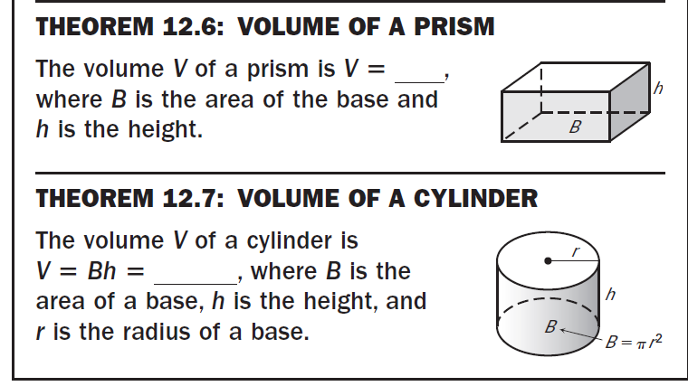
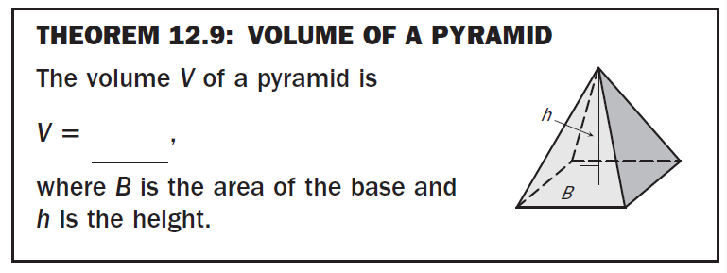
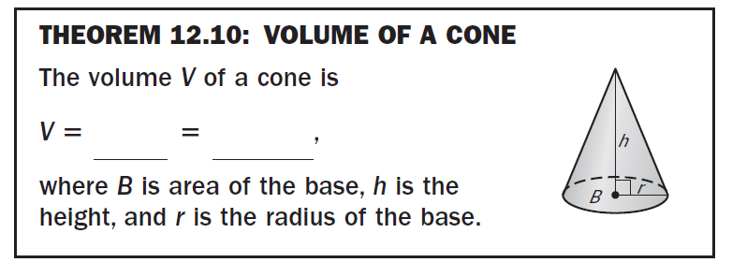
Volume Practice Problems

Example 1
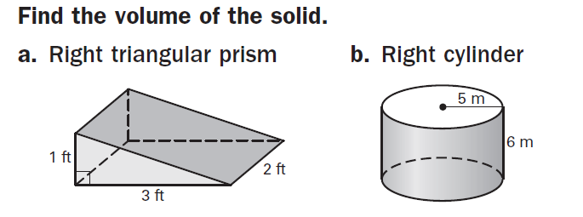

Example 2

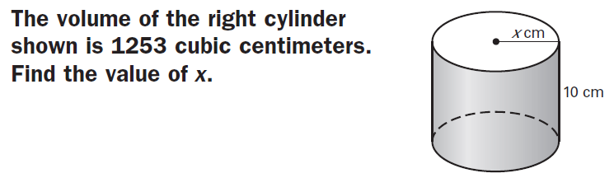
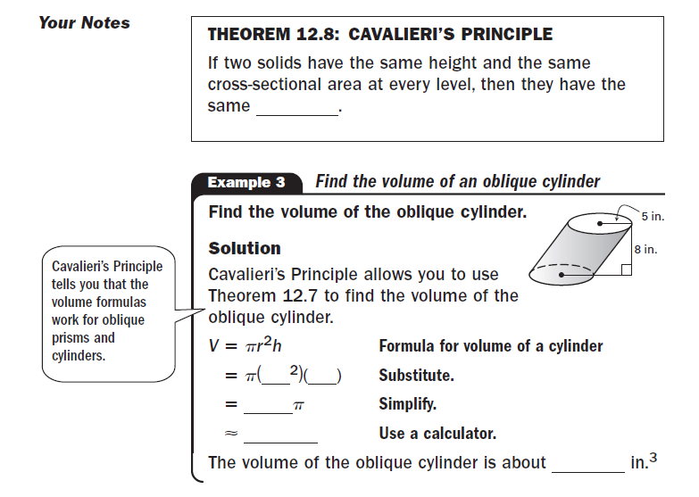

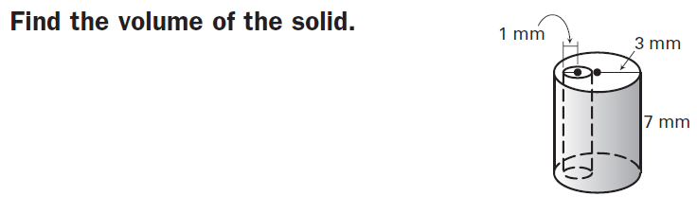

Day 1 HW:
p. 823 #7, 8, 10, 11, 15, 16, 19, 20, 24, 25

Cones and Pyramids Example Problems

Example 1

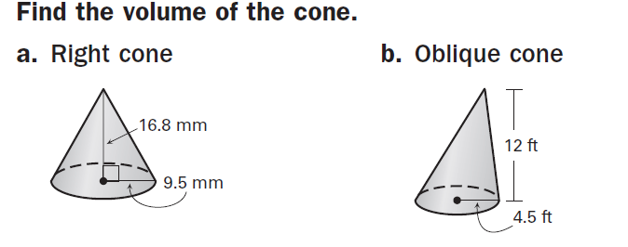

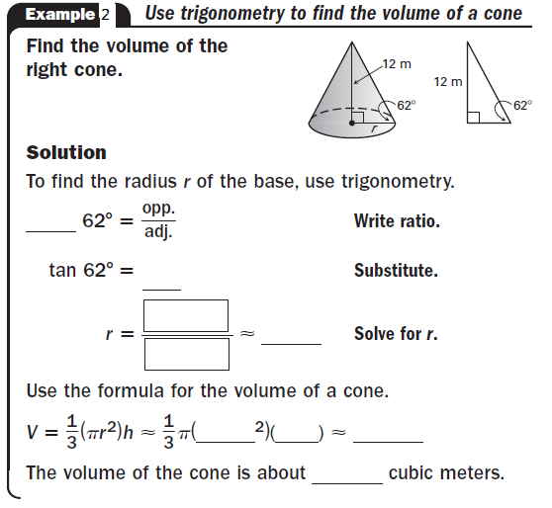

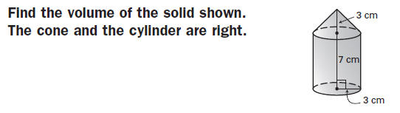

Day 2 HW:
p. 832 #3-7 all, 9, 12, 13, 17, 20, 21, 23, 24

