Name: ________________________ _____ Date: _________________

Geometry- Chapter 5 Test Review

$\overline{MP}$ is the midsegment of the triangle. Find the value of x.

1. 2.
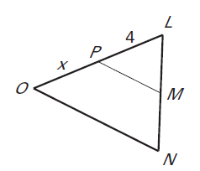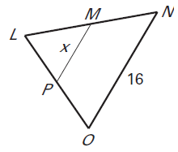

3. In the diagram, U, V and W are midpoints of $∆XYZ$.

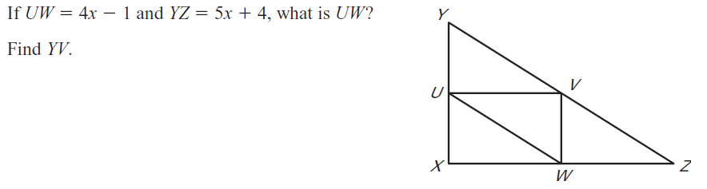

4. Find the unknown coordinates.
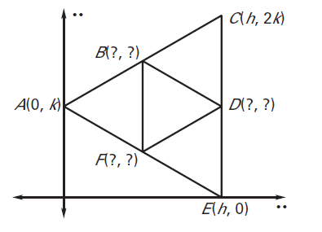

5. Given: O is the circumcenter of $∆MNP$.
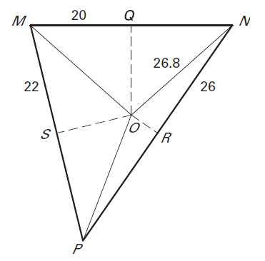
Find the length of the given segments.

MN=

OP=

SP=

MP=

6. Point T is the incenter of the triangle.
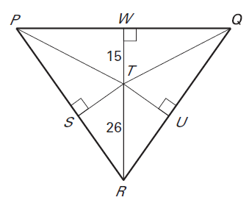
Find the lengths of the following segments.

SR=

TU=

ST=

7.
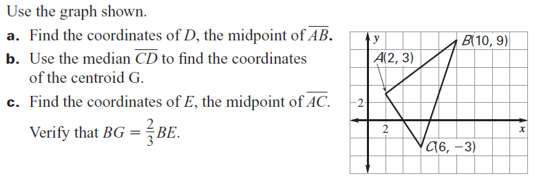
8. For the given triangle, ∠ J < ∠ K< ∠ L. Find all possible values of x.
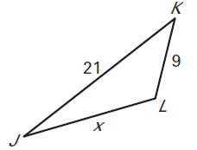

9. List the sides from shortest to longest. 10. List the angles from smallest to largest.

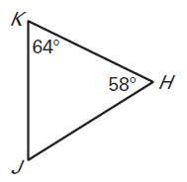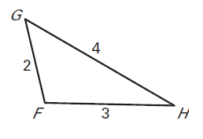

11. Point S is the centroid of the triangle. TV= 9.
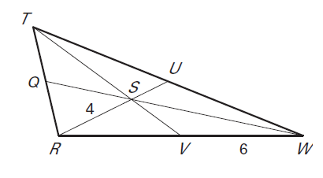
Find the lengths of the following segments.

SU=

RU=

RV=

RW=

TS=

SV=

12. Can you form a triangle with the following lengths?

a. 20 inches, 8 inches, 28 inches b. 3 feet, 6 feet, 7 feet

c. 48 inches, 2 feet, 3 feet d. 2 yards, 3 yards, 10 yards

13. Describe the possible lengths of the triangle given two side lengths.

a. 12 inches, 6 inches b. 3 feet, 8 feet

c. 12 feet, 5 yards d. 21 inches, 10 inches

