Section 4.2- Apply Congruence and Triangles

Objective: To determine if shapes are identical

Do Now:

In two congruent figures, all the parts of one figure are congruent to the corresponding parts of the other figure.

Determine whether or not the statement is true or false. Please write true or false.

In congruent polygons, corresponding sides are congruent. ______________

In congruent polygons, corresponding angles are congruent. ______________

What does this mean about their angle measure and segment lengths?

Congruence Statements

Always list corresponding vertices in _____________________________.

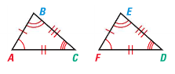
Corresponding Angles
Corresponding Sides

How can you write a congruence statement for the triangles? Be sure to match the corresponding vertices.

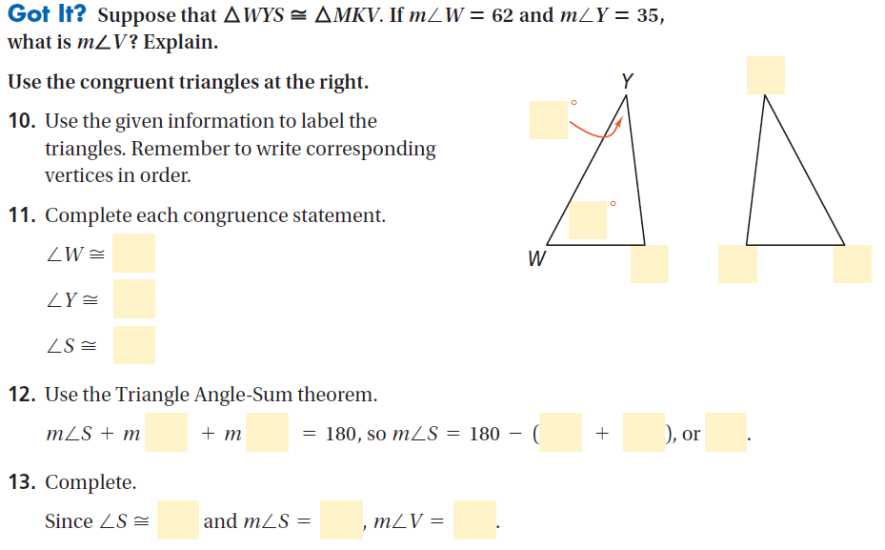

Third Angles Theorem  If two angles of one triangle are congruent to two angles of another triangle, then  ______________________________________. | 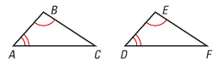  If ∠ A ≅ ______, and ∠ B is ≅ ________, then _________________.

Note: We just used the third angles theorem in the previous example without even knowing it!

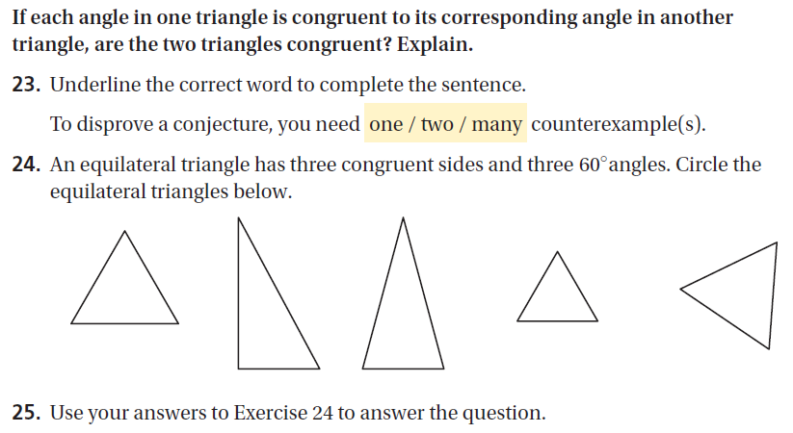

HW:

p. 228-229 #4-12 all, 22, 26, 33

